**2. Descriptive Statistics**

1) Sample Statistics

In this part, we report statistics including Means, Standard Deviations(SD), Skewness Coefficients, Kurtosis Coefficients, Betas, Stationary or not, Estimating Distribution.

2) Monthly Prices

The monthly prices plots are showed in Appendix Figure 1, 2, and 3. Each plot includes monthly closing price for five assets with a separate S&P500 curve. We can see from Figure 1 that ADM, AAPL, BAC, FCX are relatively plat with COKE has a greater volatility compared to other four assets. The range is approximately 0 to 200, and they are under S&P index. In Figure 2, MDT has a increasing trend compared to the flatness in F, GE, MRO, PFE. All of them are under S&P 500 index and MDT is the closest one to the index. The range is about 5 to 70. In addition, in Fugure 3, SIRI, SBUX, VALE, VZ are below S&P 500 index. X is above the index at the beginning and it has more volatility than the others. The range is about 0 to 60.

3) Monthly Returns

The monthly returns plots are showed in Appendix Figure 4. From the plots, we can see that the change for each asset is similar to the change in S&P500. Most of them are relatively stationary over time, and most of the assets fluctuate about the means are reasonable. We will have outlier test in part 6) with carefully investigation and analysis about the outliers and reasons that may explain the big changes.

4) Equity Curve

The equity curve of all the assets and S&P 500 is plotted in Appendix Figure 5, and the separate plots are in Appendix Figure 6. From this plot, we can compare the change in value of the assets over a period of time. We can see that approximately seven curves are below S&P 500 curve, which includes AMD, BAC, FCX, F, MDT, X, VALE.

5) Histogram and Box Plot

The histograms and box plots are in Appendix Figure 7 and Figure 8. We can see from the histograms that most of them have bell shape curve. COKE, VALE, SIRI and F are skew to left, SBUX is skew to right. MRO and VZ does not have smooth curve than the others. From the box plots, we can see outliers exist and we will closely look at them in the next part. The medians are close for the assets and SBUX has the highest median.

6) Outliers

7) QQ Plot and Normality Test

The QQ plots of all the assets are in Appendix Figure 9. The plots show that the lines are close to linear, especially after deleting outliers. This means that it is reasonable to assume normality of our assets. VZ may be the one that most likely nonlinear.

We also use Kolmogorov-Smirnov Tests to test normality. All the p-values are really small. They all pass the normality test.

8) Stationary Test

We use the Priestley-Subba Rao (PSR) test for nonstationarity. The result showed below. We can see that five of them are nonstationary, which includes COKE, FCX, F, MRO and SIRI.

|  |  |  |  |  |  |
| --- | --- | --- | --- | --- | --- |
|  | **AMD** | **AAPL** | **BAC** | **COKE** | **FCX** |
| **T** | 0.305 | 0.102 | 0.305 | 0.0008 | 0.012 |
| **Stationary** | YES | YES | YES | NO | NO |
|  | **F** | **GE** | **MDT** | **MRO** | **PFE** |
| **T** | 0.017 | 0.07 | 0.149 | 0.0022 | 0.711 |
| **Stationary** | NO | YES | YES | NO | YES |
|  | **SIRI** | **SBUX** | **X** | **VALE** | **VZ** |
| **T** | 2.59e-5 | 0.138 | 0.264 | 0.053 | 0.067 |
| **Stationary** | NO | YES | YES | YES | YES |

9) Sharpe’s Ratio and Betas

The Sharpe’s Ratio is showed below, and the sharpe’s ratio for S&P 500 is 0.896. We can see that SBUX has the largest Sharpe’s Ratio which is 1.638, and X has the lowest Sharpe’s Ratio which is -0.37.

The betas are showed below, and the beta for S&P 500 is 1 since it is the market risk. We can see that beta for AMD, BAC, FCX, F, GE, MDT, MRO, SIRI, X, and VALE are greater than 1, and beta for AAPL, COKE, PFE, SBUX, and VZ are smaller than 1. Since beta is a measure of how aggressive the asset and how sensitive it is to market movement, we can conclude that AMD, BAC, FCX, F, GE, MDT, MRO, SIRI, X, and VALE are aggressive assets, and AAPL, COKE, PFE, SBUX, and VZ are non-aggressive asset.

|  |  |  |  |  |  |
| --- | --- | --- | --- | --- | --- |
|  | **AMD** | **AAPL** | **BAC** | **COKE** | **FCX** |
| **Sharpe’s Ratio** | -0.08 | 1.109 | 0.235 | 0.985 | -0.237 |
| **Beta** | 2.078 | 0.928 | 1.541 | 0.477 | 2.273 |
|  | **F** | **GE** | **MDT** | **MRO** | **PFE** |
| **Sharpe’s Ratio** | 0.357 | 0.753 | 0.732 | 0.066 | 0.876 |
| **Beta** | 1.465 | 1.387 | 1.103 | 1.579 | 0.790 |
|  | **SIRI** | **SBUX** | **X** | **VALE** | **VZ** |
| **Sharpe’s Ratio** | 0.924 | 1.638 | -0.37 | -0.6 | 0.919 |
| **Beta** | 1.621 | 0.789 | 1.861 | 1.493 | 0.483 |

10) Scatter Plots and Correlation Matrix Heatmap

The pairwise scatter plots are showed in Appendix Figure 10. The correlation matrix heatmap is showed in Appendix Figure 11. From the plots, we can conclude that FCX and VALE are correlated with 0.73 showed in the correlation matrix heatmap. And the correlation is positive. So we can expect changes in the return of FCX may have relationship in the changes in VALE. It is reasonable to see that these two are in the same sector with related industries, that FCX is in the cooper industry, and VALE is in the industrial Metals & Minerals industry. Also, MRO and FCX have a relatively moderate positive correlation with 0.66 showed in the heatmap. These two are from same sector which is basic materials, so it is reasonable to expect some kind of relationship between them.

11) Fitting Distributions

In this part, we use the returns to fit distributions. We want to see which one of Normal, t, and generalized error distribution is a better fit to the data. The result showed below, with AIC values.

|  |  |  |  |  |  |
| --- | --- | --- | --- | --- | --- |
|  | **AMD** | **AAPL** | **BAC** | **COKE** | **FCX** |
| **Normal** | -73.23 | -170.50 | -124.59 | -156.54 | -77.52 |
| **t**  **GEF**  **Best one** |  |  |  |  |  |
|  | **F** | **GE** | **MDT** | **MRO** | **PFE** |
| **Normal** | -147.57 | -182.99 | -208.99 | -129.59 | -229.25 |
| **T**  **GEF**  **Best one** |  |  |  |  |  |
|  | **SIRI** | **SBUX** | **X** | **VALE** | **VZ** |
| **Normal** | -117.15 | -200.44 | -83.71 | -109.56 | -229.30 |
| **t**  **GEF**  **Best one** |  |  |  |  |  |

**Appendix:**

**Monthly Price Plot**

**Monthly Return Plot – netreturn**

**Monthly Return Plot–logreturn**

**Equity Curve**

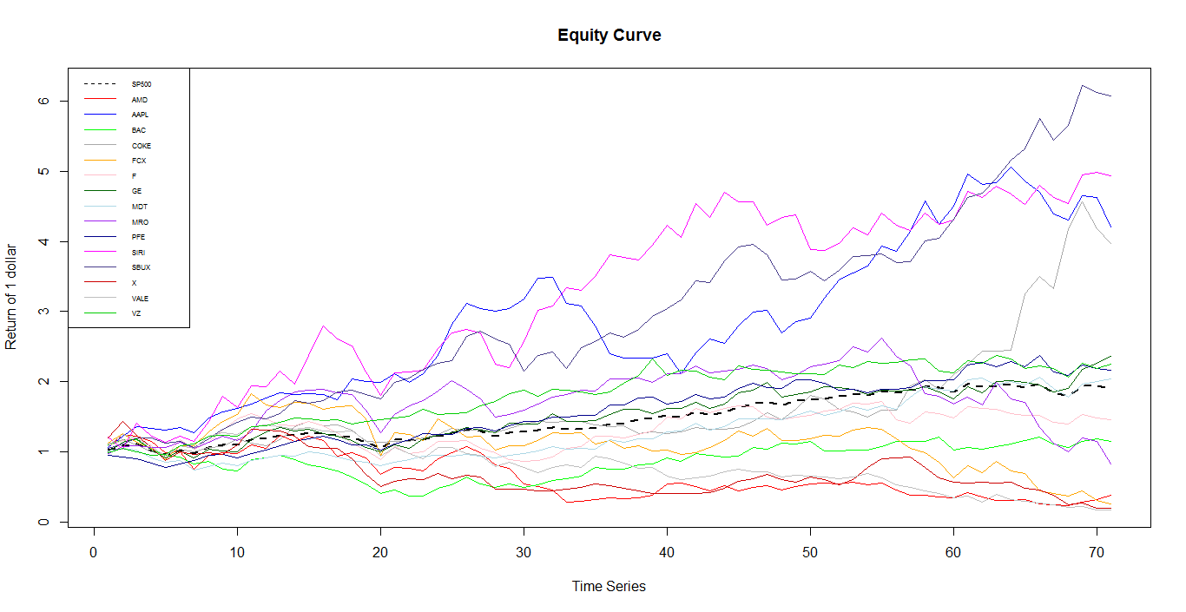

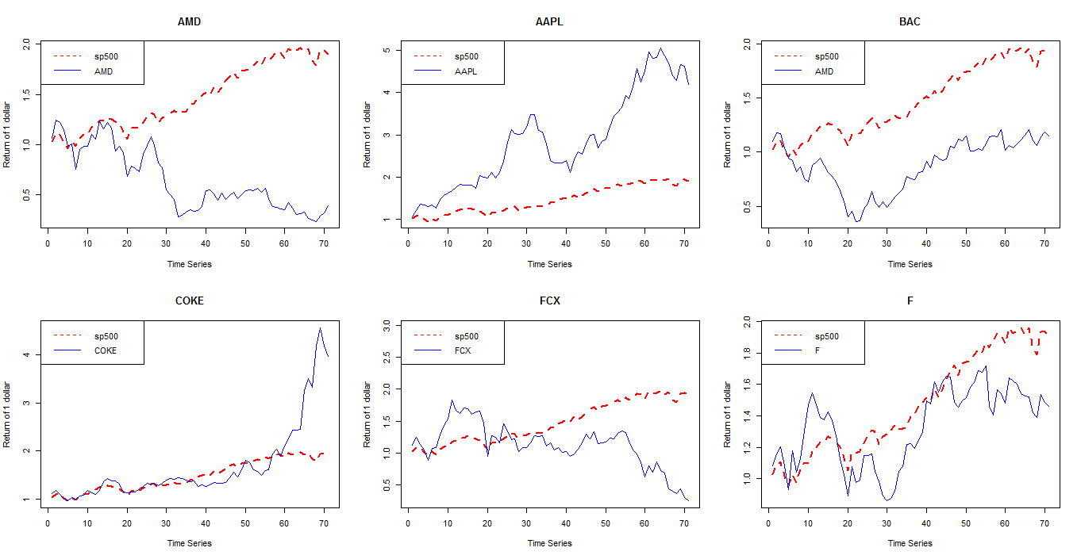

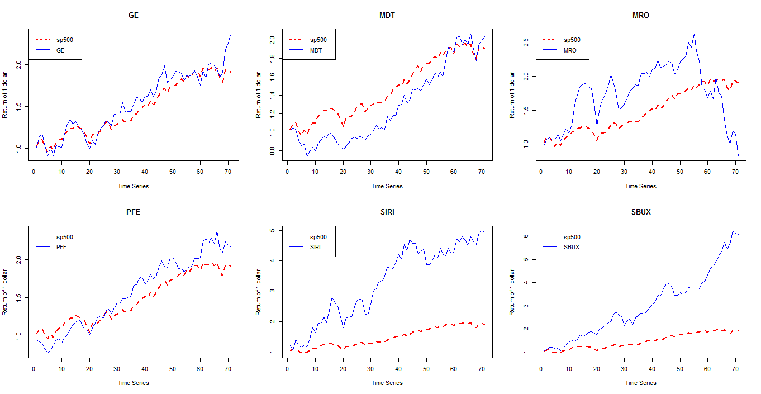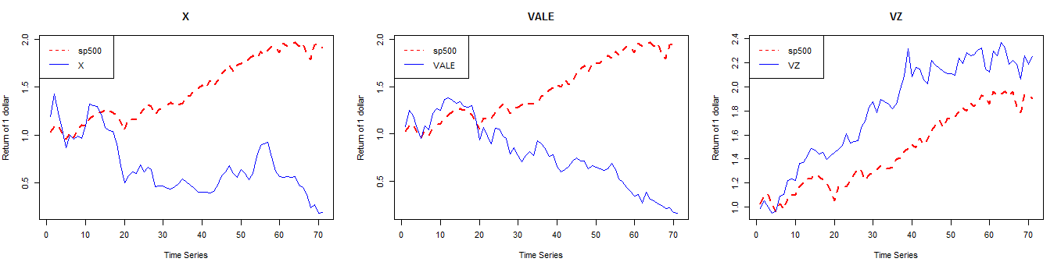

**Histogram**

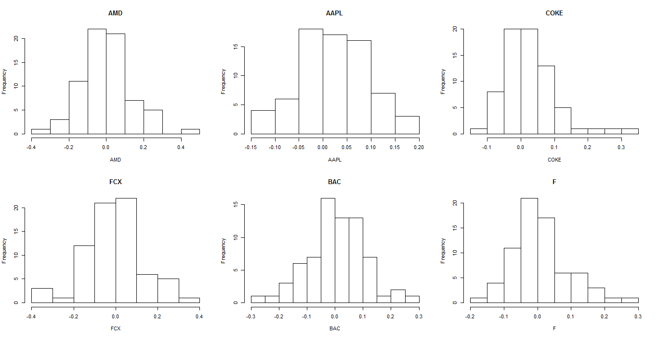

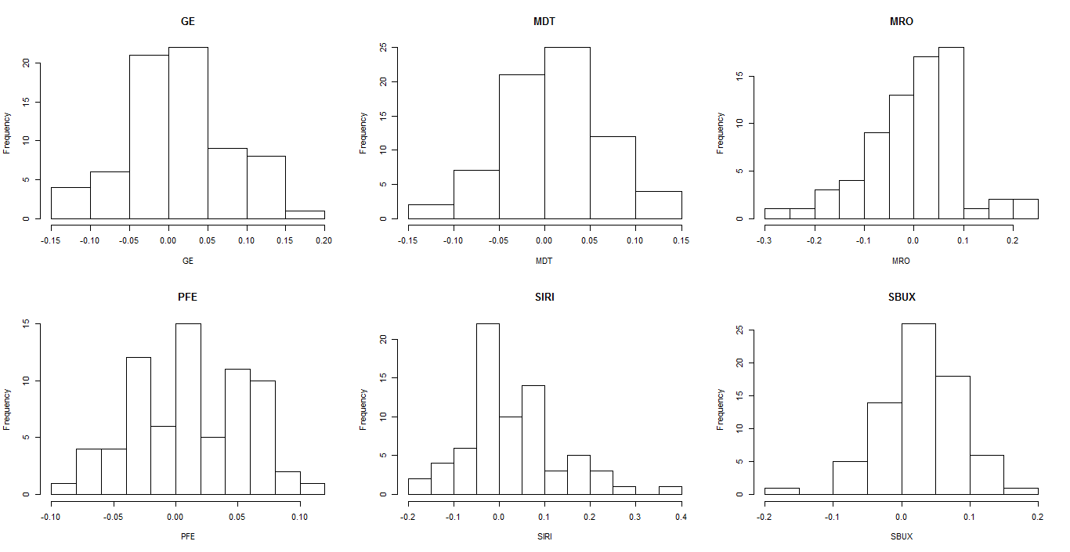

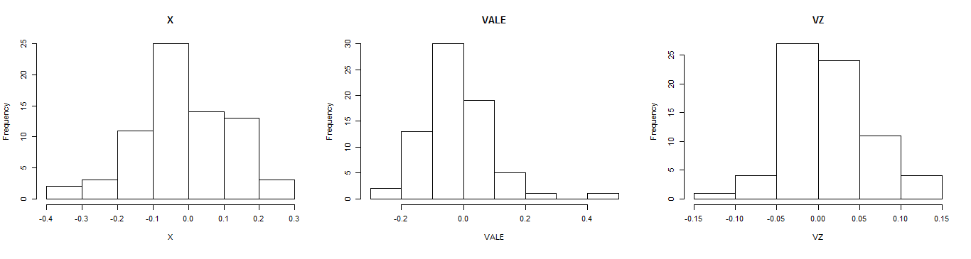

**Boxplot**

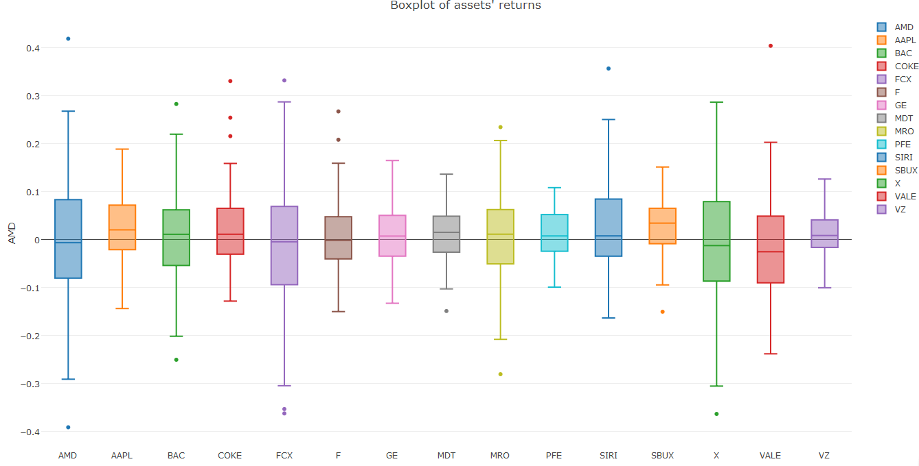

**QQ-Plot**

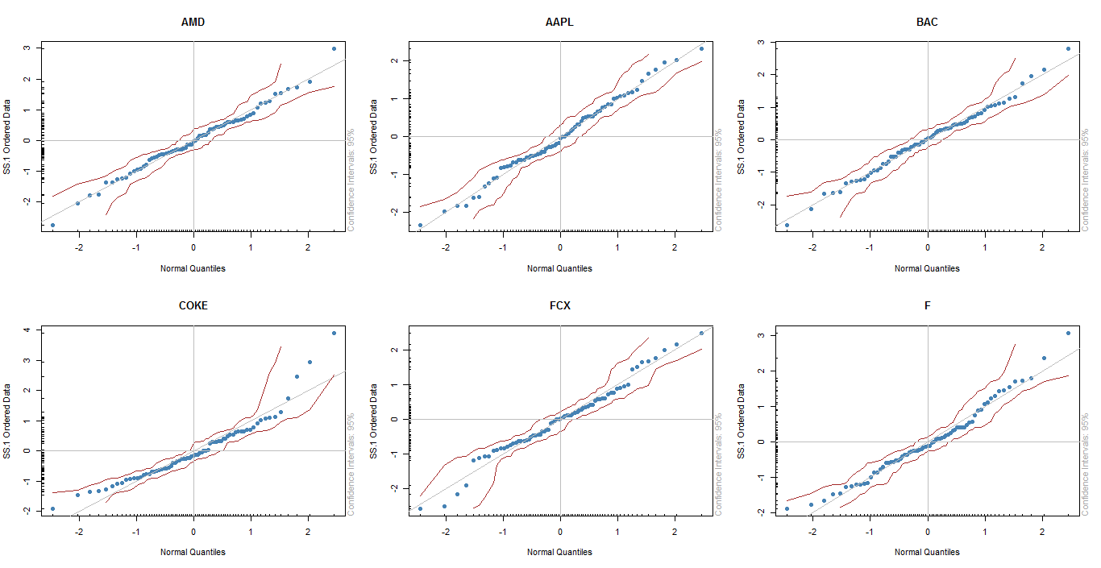

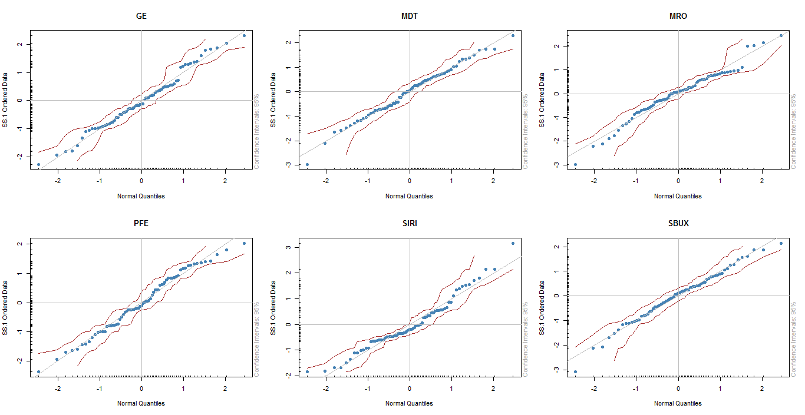

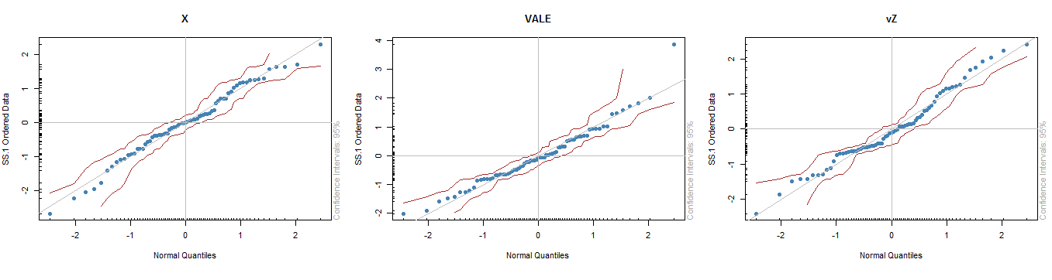

**Scatter Plot**

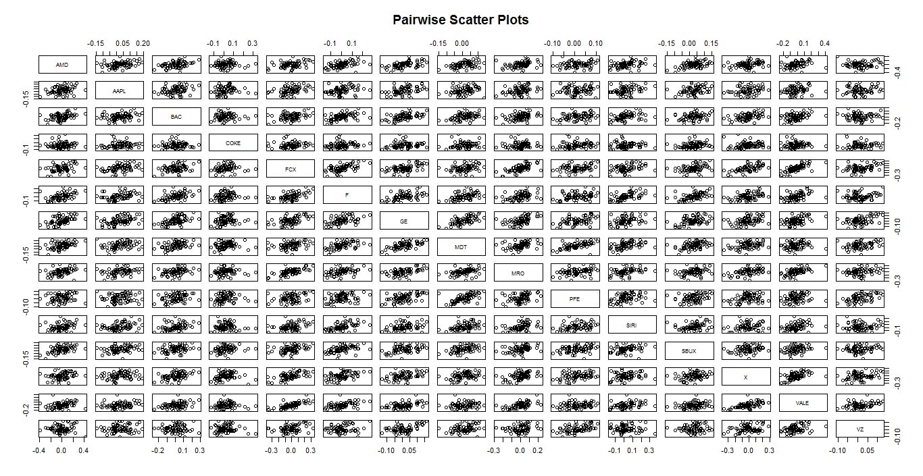

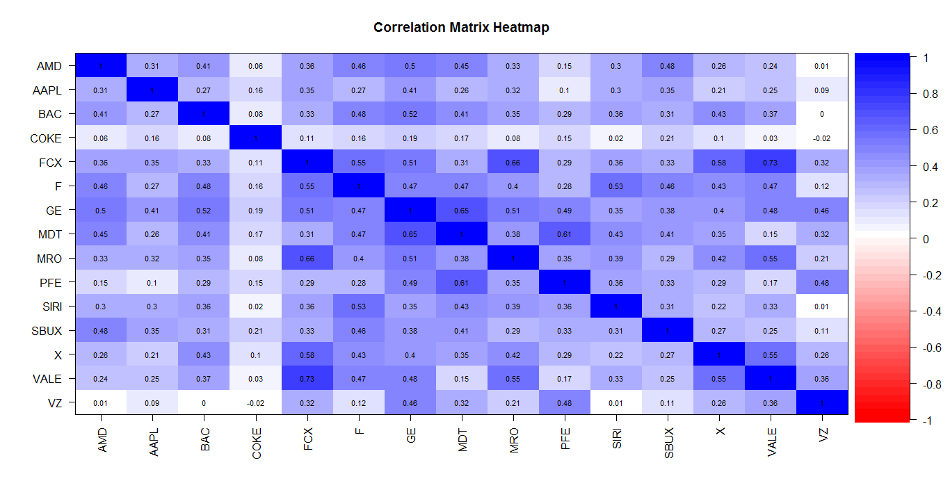

**Portfolio Theory**

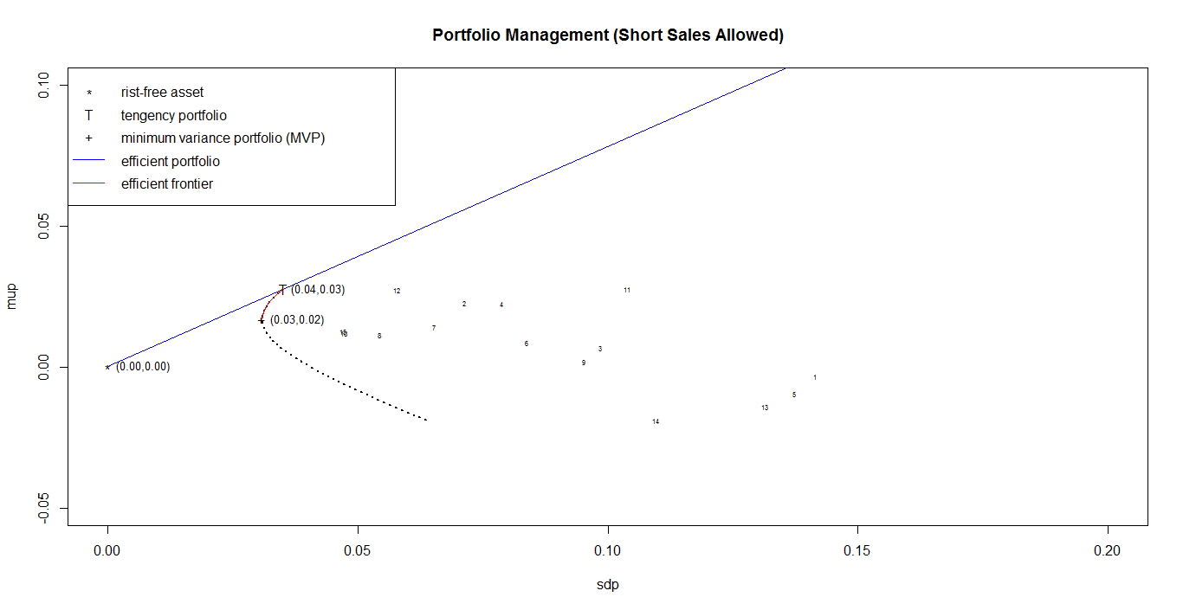

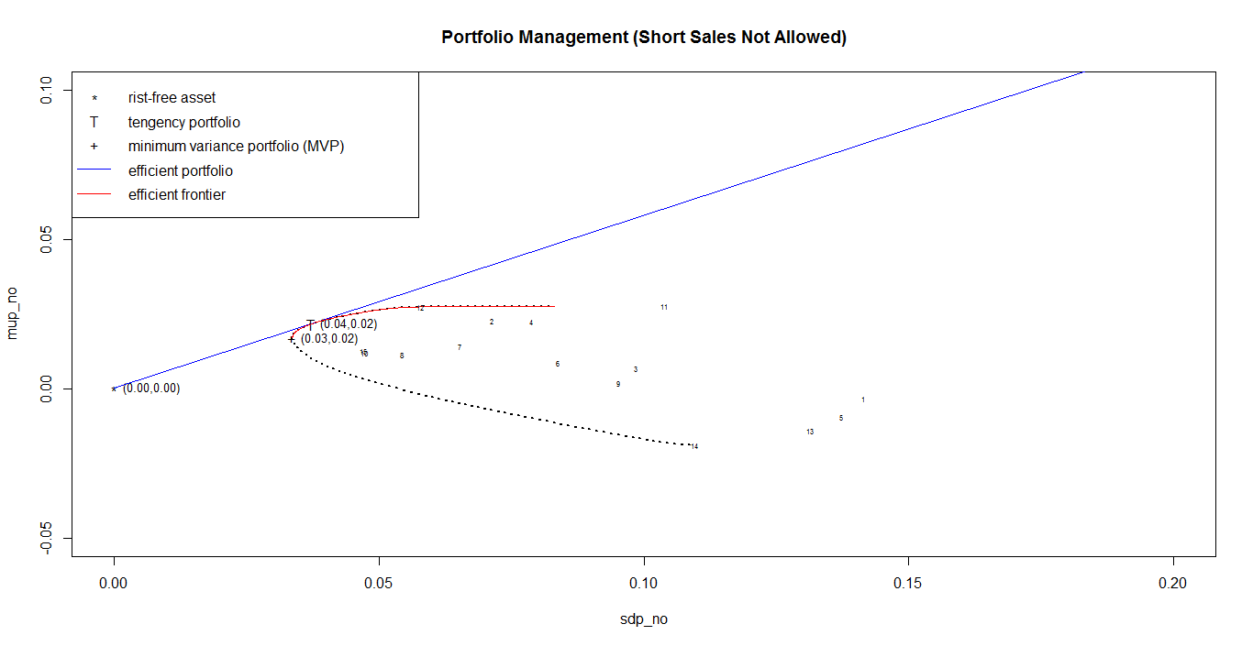

**PCA**

